[Agnatha](https://en.wikipedia.org/wiki/Agnatha#:~:text=Agnatha%20(%2F%CB%88%C3%A6%C9%A1n,(conodonts%20and%20ostracoderms)%20species.), the Scorched Sea

Bottom bitter fish

**Our hero’s Journey**

Start: comfortable hometown of Dry Haven (five days of travel to leave Dry Haven, cannot use sails) on the Great Arroyo.

Follow the Arroyo up its many tributaries until you reach the mountains and The Last Green Pasture East of Arroyo , wait there until the winds change.

“What do you plan to do with your Dune beetle, surely you’re not going to need her with this here contraption of yours?”

Venture onto scorched earth, into the wind, travel quickly, maintain glue, tacking required.

**Geography**

GENERAL: Mountains to the west, storms to the east, coast to the north.

The Great Arroyo is a…

Dry river

useful for keeping out of worst of sun

most settlements here

Depression in an aquifer, good for finding water.

Possible ends of the Great Arroyo:

Groundwater flow (Goes underground)

~~Nubian~~ [Myxini Aquife](https://www.reddit.com/r/geology/comments/adt0ij/comment/edkfzdb/?utm_source=share&utm_medium=web2x&context=3)r

**Climate**: Extremely hot.

Residual heat from the afternoon sun makes it impossible to step onto the surface until after dusk.

**Society**

Most either live in dugouts under strong stone or ravine towns hidden by the face of Jove

Dusk Goer/Dawn Comer - someone who travels during dusk.

Astronomy is widely regarded as the most respect field that a magician can

“The never saw, the never seen, the never sea.” In reference to the fabled sea in the east.

**Creatures**

**History**

Once great civilisation in lush green forests.

Huge flood, followed by drought.

Civilization falls.

Retreats to the Great Arroyo and the coast, however they are split from one another and branch off into different societies, neither knowing of the other’s existence.

Relative prosperity, however, the first aquifer layer soon depletes, leading to the second collapse not long after.

People now have to frack deep into the Earth (second aquifer layer *first confined*) to collect water.

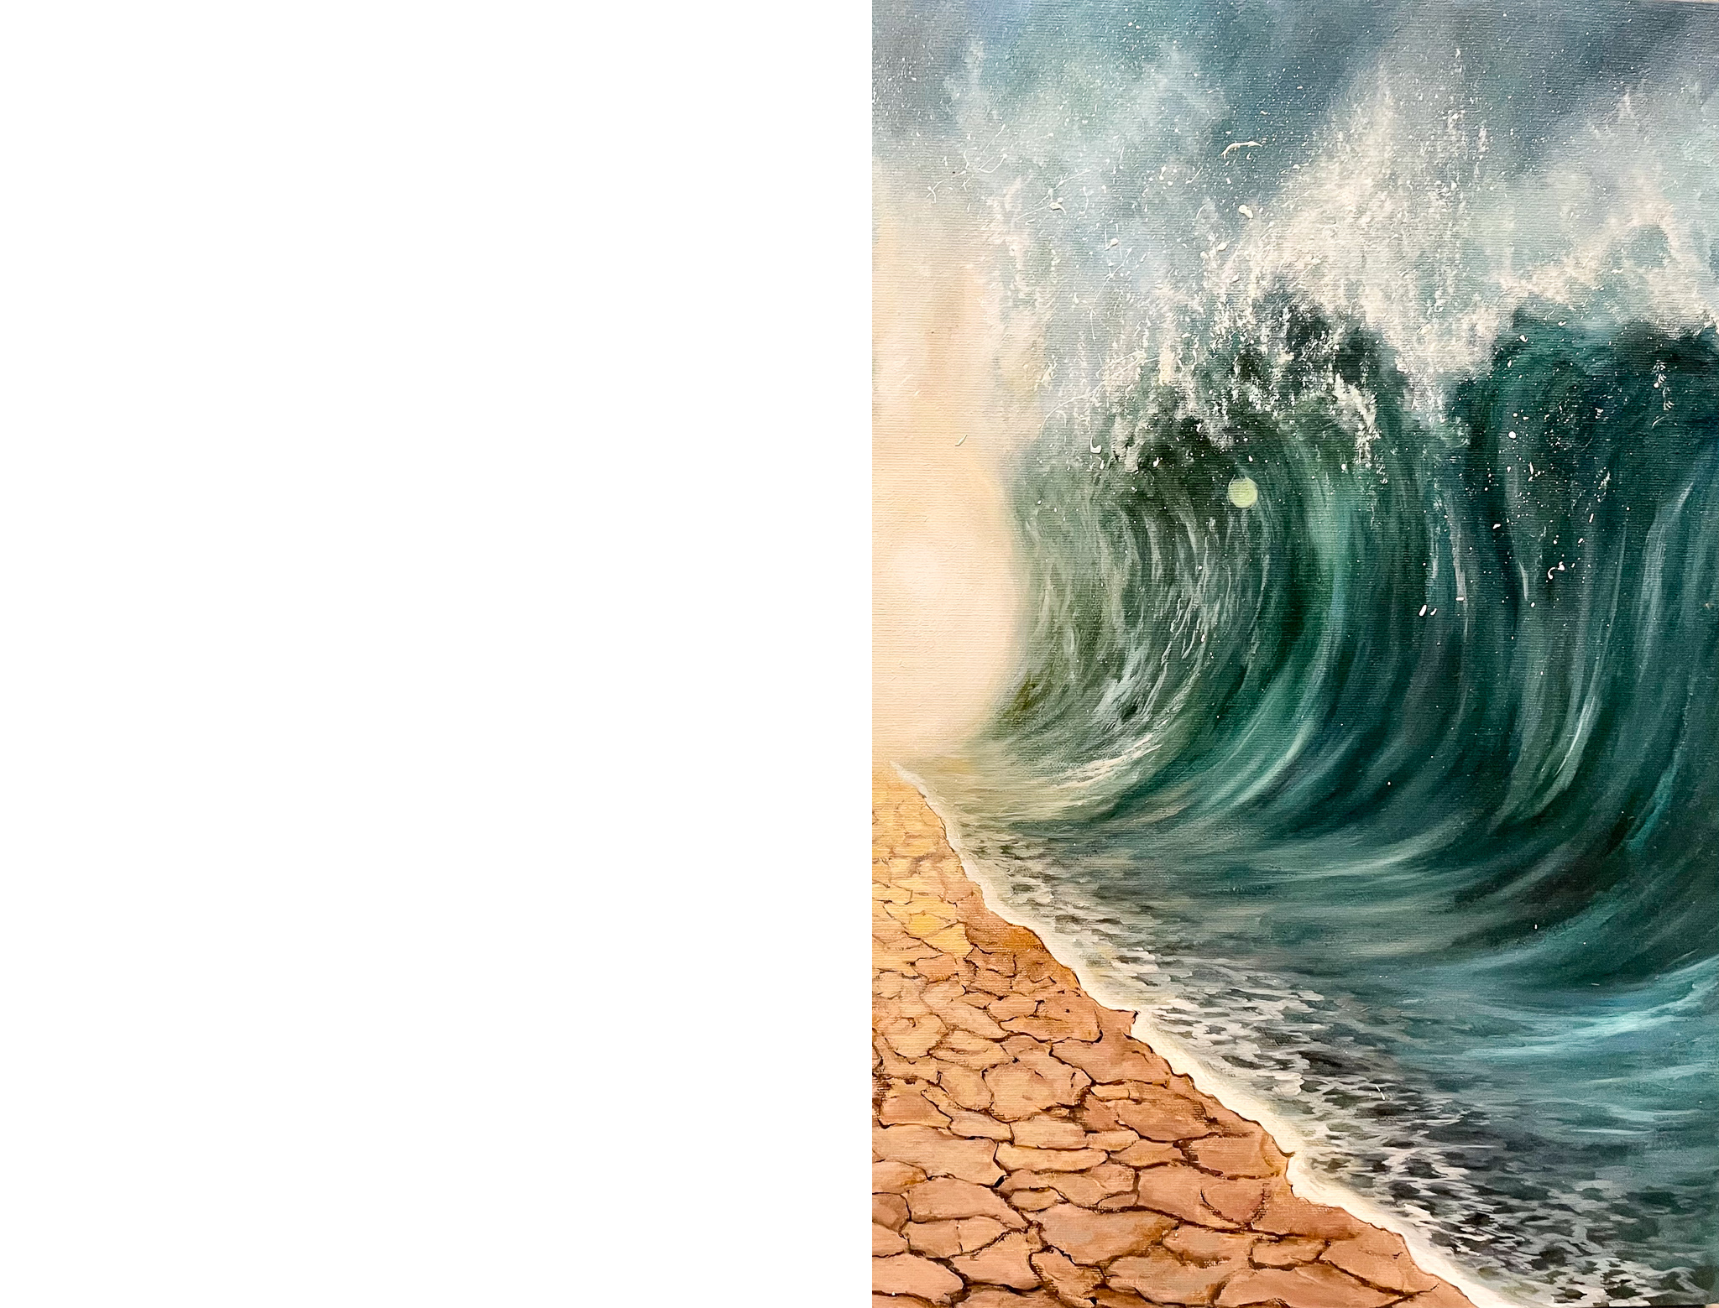

The barrier of water prevent the old sea from filling.

**Religion**

Name: Jove, the father, god of the closest star.

Symbol: Sun

Relationship: To be feared.

Name: Mother.

Symbol: the land

Relationship:

Name: Brother/sister, Giver of knowledge.

Symbol: Telescope, dynamite.

Relationship: Neutral.

Once every 700 years, the winds change direction completely from North and South to East and West (Seawardly). This leads to a period of fertility, discovery, and exploration. Those born during this period are said to have been Hallowed by the Earth itself.

[Traverser](https://en.wikipedia.org/wiki/Land_sailing) - A sail-driven craft designed to traverse the Scorched Sea.

Made of [BAMBOO] and Giant Dune Beetle glue and running on three wheels, it was built for the purpose of confirming the existence of the coast by a brilliant astronomer who predicted that the north winds would bring with it [BAD OMEN STUFF].

Plot:

Single father sends his child on a journey to find the sea.

Glue melts if spent too long in the sun.

Can be pulled by Giant Dune Beetles if the need arise.

“Accustomed to much heavier loads, she pulls the craft effortlessly. It feels like she could go for days without stopping, or maybe hours at speed.”

The زفير (Zafir)

~~While most do not believe in a higher power, during the first of the cooling winds (a period in which cold air was ) (equivalent to Jove)~~

~~https://www.nature.com/articles/srep36300~~